******COMSATS University Islamabad (Lahore** **Campus)**

**Assignment <2> FALL 2023**

|  |  |  |  |  |  |  |  |  |
| --- | --- | --- | --- | --- | --- | --- | --- | --- |
| Course Title: | Artificial Intelligence | | | Course Code: | | CSC462 | Credit Hours: | 3(2,1) |
| Course Instructor: | Dr. Atifa Athar | | | Programme Name: | | BS Computer Science | | |
| Semester: | 6th | Batch: | **SP21** | Section: | **A** | Date: | 17-10-2023 | |
| **Due Date:** | **21-10-2023** | | | **Maximum Marks:** | | | **10** | |
| **Student Name:** | **Hassan Mahmood** | | | **Registration No.** | | | **SP20-BCS-114** | |
| **Important Instructions / Guidelines:**   * **No late submissions will be accepted.** * **All assignments are required to be submitted using the attached template only.** | | | | | | | | |

**Question No 1. Marks: 5 + 5=10**

***CLO: <3>; Bloom Taxonomy Level: <Applying>***

Comsats University Islamabad (CUI) wants to start a new degree program: BS. in Artificial Intelligence (AI).

Suppose the degree program is associated with the following courses:

15-211 Fundamental Data Structures and Algorithms

15-212 Principles of Programming

15-381 Artificial Intelligence: Representation and Problem-Solving

15-681 Machine Learning

80-310 Computational Intelligence

21-484 Graph Theory

70-122 Accounting

70-311 Psychology

19-601 Data Science

In order to graduate from the degree program, one must complete the following four requirements:

* Algorithms Requirement: (15-211 AND 15-212) OR (15-211 AND 15-381) OR (15-681 AND 21-
* 484)
* Machine Learning Requirement: 15-381 OR 15-681 OR 80-310
* Communications Requirement: 21-484 OR 70-311 OR 70-122
* Data Science Requirement: 15-381 OR 19-601OR 15-681

In addition, the department imposes the following restrictions:

* Information Aggressiveness Restriction: So that they can’t make their programs TOO smart, students
* can take only one class from the set 15-381, 15-681, and 19-601.
* Basic Arithmetic Restriction: Students can’t take both 15-211 and 70-122.
* Organization Restriction: Students can’t take both 21-484 and 70-311.

Finally, courses cannot be used to count towards multiple graduation requirements - so if you use 15-381 to fulfill part of the Algorithms requirement it can’t count towards either the Machine Learning Requirement or the Data Science Requirement.

1. **ALI just started his first year at CUI and needs to graduate as soon as possible. Suppose all he has left to take are AI-required classes. Model the problem of his trying to find a set of classes to satisfy all requirements as a CSP (Hint: the requirements should be your variables). What are the variables, Constraints, and initial domains for each of your variables?**

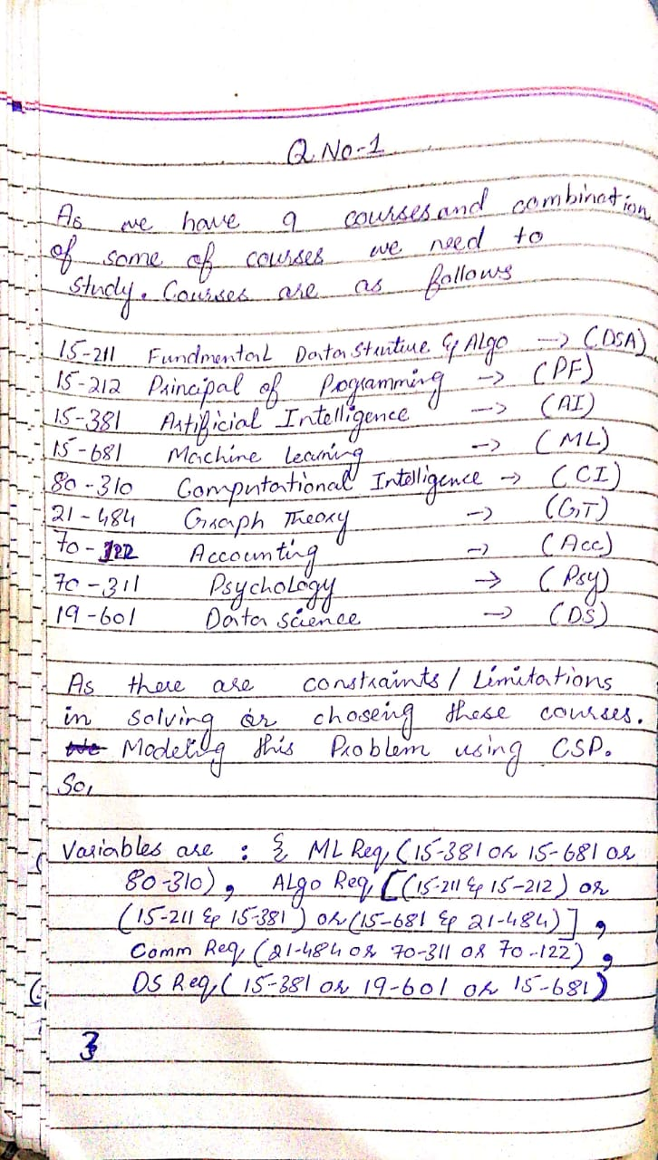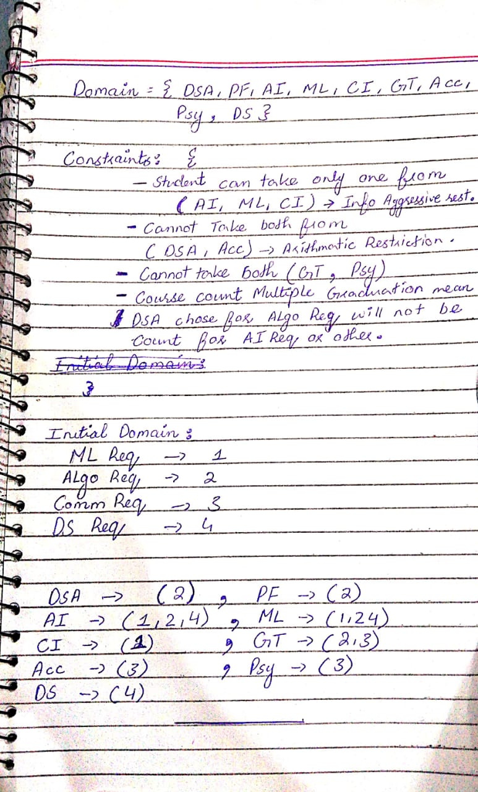

1. **Show a DFS with a backtracking tree for finding a set of classes that fulfill all requirements using a variable order of the requirements in the order they are listed above, and using a value order that selects the lowest department/course number remaining in a variable’s domain. Indicate which constraints were violated whenever the DFS needs to backtrack.**

**(Note: to get full credit you must show the full DFS tree and not just the classes that are used to fulfill each requirement)**

1. **Show a BFS with a backtracking tree for finding a set of classes that fulfill all requirements.**